NEW ASSET REQUEST
CLIENT REFERENCE:
URL : https://web2ess.elitehrms.com
UserName : DC0003
Password : M@ster
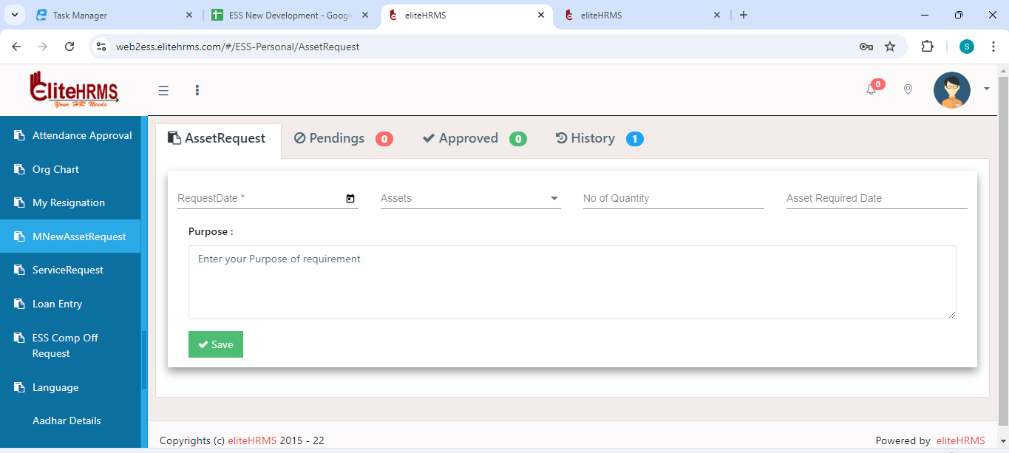
- Initially to call “GetAssetRequestList”
- Any one asset have edit call “GetAssetData”
- Post No need said by Dinakaran.
Over all get api :
https://localhost:44349/api/Personal/GetAssetRequestList
{
"Response": {
"_status": "Success",
"_code": "111",
"_Source": "GetAssetRequest",
"_Description": "",
"_Details": "",
"_TransID": null,
"_Timestamp": "20241005045732"
},
"ScreenID": 0,
"AssetDetails": [
{
"AssetRequestID": 1,
"AssetRequestNo": "REQ/24-25/0001",
"AssetRequestDate": "0001-01-01T00:00:00",
"RequestDate": "26/09/2024",
"EmployeeID": 250,
"Employeecode": "INOVA-0002",
"EmployeeName": "K Subramania Bharathiyar",
"LocationID": 2608,
"TransactionstatusID": "6863",
"Location": "Chennai",
"Transactionstatus": "Finalized",
"IssueSummary": ""
}
],
"AssetData": []
}
Edit Get api :
https://localhost:44349/api/Personal/GetAssetData?AssetRequestID=1
{
"Response": {
"_status": "Success",
"_code": "111",
"_Source": "GetAssetData",
"_Description": "",
"_Details": "",
"_TransID": null,
"_Timestamp": "20241005045900"
},
"ScreenID": 0,
"AssetDetails": [
{
"AssetRequestID": 1,
"AssetRequestNo": "REQ/24-25/0001",
"AssetRequestDate": "0001-01-01T00:00:00",
"RequestDate": "26/09/2024",
"EmployeeID": 250,
"Employeecode": "INOVA-0002",
"EmployeeName": "K Subramania Bharathiyar",
"LocationID": 2608,
"TransactionstatusID": "6863",
"Location": "Chennai",
"Transactionstatus": "Finalized",
"IssueSummary": ""
}
],
"AssetData": [
{
"AssetNameID": 1043,
"AssetName": "",
"NoofAsset": "1",
"Date": "0001-01-01T00:00:00",
"RequiredDate": "13/06/2024"
},
{
"AssetNameID": 1044,
"AssetName": "",
"NoofAsset": "1",
"Date": "0001-01-01T00:00:00",
"RequiredDate": "14/06/2024"
},
{
"AssetNameID": 1050,
"AssetName": "A1001",
"NoofAsset": "1",
"Date": "0001-01-01T00:00:00",
"RequiredDate": "26/09/2024"
}
]
}

